# Michigan College **AVERAGE** Requirements Worksheet

Name: __________________________________________________________________

Approximate GPA: ___________________ SAT Score: _____________

**Colleges in Michigan: GPA & SAT Tiers**

GPA Averages of college freshman class based on information found on institutions’ websites. Average SAT is estimated based on ACT information on institutions’ websites and converted through The College Board’s concordance chart. To verify information is accurate, contact the admissions office.

Description: https://www.ecsi.net/img/logo/acy9_logo.jpgDescription: http://www.ece.mtu.edu/ee/faculty/rezaz/wireless_lab/mtu_logo.jpgDescription: http://www.cappex.com/assets/c-168546/logos/2011-03-02_13-07-06.463.jpgDescription: Description: Wayne State University logo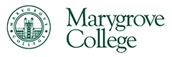Description: finlandiaDescription: andrews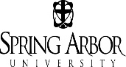Description: http://www.svsu.edu/uploads/RTEmagicC_7d66888c32.jpg.jpgDescription: kendallDescription: davenport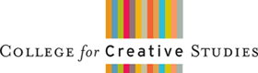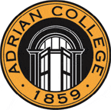

**3.8-4.0**

**1350-1600**

**\*Open**

**Admissions**

**Avg. GPA**

**Avg. SAT**

**3.5-3.8**

**1130-1380**

**3.3-3.5**

**1060-1230**

**2.8-3.2**

**940-1120**

**2.5-2.8**

**860-1010**

* Alpena CC
* Baker College
* Bay College
* Delta College
* Glen Oaks CC
* Gogebic CC
* Grand Rapids CC
* Henry Ford CC
* Jackson CC
* Kalamazoo   
  Valley CC
* Kellogg CC
* Kirtland CC
* Lake Michigan   
  College
* Lansing CC
* Macomb CC
* Mid-Michigan CC
* Monroe County CC
* Mott CC
* Muskegon CC
* North Central   
  Michigan College
* Northwestern  
  Michigan College
* Oakland CC
* Schoolcraft College
* Southwestern  
   Michigan College
* St. Clair   
  County CC
* Washtenaw CC
* Wayne County CC
* West Shore CC

Community Colleges No minimum GPA & ACT requirements.